REQUEST FOR PROPOSAL
Priest Community Forest Connection

RFP NUMBER: 2022-001

DESCRIPTION:
Pend Oreille River Passage Trail ~ Wetland Boardwalk and Interpretive Signs
This is a ‘design-build’ RFP ~ budget and location driven.

DUE DATE: April1, 2022
In the post office box or the physical address below,
NO LATER THAN 1:00 P.M. *

Priest Community Forest Connection
138 Main Street
P.O. Box 892
Priest River, Idaho 83856

RFP SUBMITTED BY:

COMPANY________________________

MAILING ADDRESS:________________

_________________________________

PHONE NUMBER__________________

FAX NUMBER_____________________

* It is PCFC’s intention that this project goes forward during 2022, but there are environmental objectives that must be met. The boardwalk MUST be completed by September 2022. At the time of award, these details will be worked out.

PRIEST COMMUNITY FOREST CONNECTION

PROPOSAL

SECTION I. PROPOSAL PREPARATION AND EVALUATION

- PROPOSAL PREPARATION - All proposals shall be typed or printed in ink, and signed by an authorized person of the Contractor’s firm. If errors are made, the corrections shall be initiated by the person signing the proposal.

- PREPARATION OF ENVELOPES - Place each copy of the proposal in a separate sealed envelope. On the front of each envelope, place the following information:

“SEALED PROPOSAL – IMPORTANT”
PROJECT NAME (Pend Oreille River Trail, Boardwalk and Observation Platform 2020)
DUE DATE AND TIME
COMPANY NAME

- SUBMISSION OF PROPOSALS - Submit one (1) original of the proposal and 9 copies of the proposal to:
Priest Community Forest Connection
138 Main Street
P.O. Box 892
Priest River, Idaho 83856

- CONTRACTOR’S REPRESENTATION - The Contractor, by making its proposal, represents that it has read and understands the requirements; and has visited the site and familiarized itself with the local conditions under which the work is to be performed.

- PREQUALIFICATION - Prior to the award of contract, the Contractor shall be required to submit evidence of sufficient facilities, equipment, experience and financial ability to insure completion of the work, unless waived by PCFC.

- AWARD OF CONTRACT - Award of contract, when made by PCFC, will be to the Contractor whose RFP is the most favorable, taking into consideration price and other evaluation factors. (See page 9 ~ Evaluation Criteria.) Unsuccessful firms will not automatically be notified of results.

- REJECTION OF PROPOSALS - PCFC reserves the right to reject any or all proposals, to waive minor deviations from the specifications, to waive minor informalities in the RFP process whenever it is in PCFC’s best interest, and to accept or reject all or part of this Request for Proposals, at the prices shown.

SECTION II. GENERAL REQUIREMENTS

- SCOPE OF WORK - Unless otherwise stated, the Contractor shall furnish all labor, supervision, materials, tools, construction equipment, transportation, and other items of work and costs necessary to complete the specified work.

- PROJECT - This project is for Priest Community Forest
Connection for the Pend Oreille River Passage Trail. PCFC’s representative is Liz Johnson-Gebhardt whose phone number is (208) 661-2073. The Contractor shall direct all correspondence and billings to this person.

- COMPLETION TIME - All work under the contract shall be started after the date of notice to proceed. (The date of the contract award shall be May 1, 2022). The Boardwalk portion of this contract must be completed by the end of September 2022 (due to funding requirements.) Trail work, once started, shall be completed by the date, (specified by PCFC) of November 15, 2022.

- INTENT OF SPECIFICATIONS - The apparent silence or omission of the specifications as to any detail of any work to be done or materials to be furnished means that the best general practice is to prevail, and that material and workmanship of the best quality are to be used, and interpretation of the specification shall be made upon this basis.

- GUARANTEE - The Contractor guarantees all work, labor and materials for a minimum of one year. If any unsatisfactory condition or defect develops within that time, the Contractor shall immediately place the work in a satisfactory condition and repair all damage caused by the condition or defect at its sole expense. This guarantee shall not apply to work, which has been abused or neglected by Priest Community Forest Connection.

- SUBCONTRACTORS - The Contractor shall not award any work to any subcontractor without PCFC’s approval. The Contractor is fully responsible to PCFC for the acts and omissions of its subcontractors and no contractual relationship shall be created between any subcontractor and PCFC.

- INSURANCE - During the term of the contract, the Contractor shall maintain in force at its own expense and provide PCFC with evidence, the below insurance:

  - Statutory Workers’ Compensation insurance for the State of Idaho as required by law, covering Contractor’s employees. Such coverage shall also provide Coverage B, Employer’s Liability limits of at least $1,000,000/$1,000.000/$1,000,000.

  - Property Damage Liability insurance to include Contractor’s Property Damage Form B Third Party Liability insurance with limits of at least $500,000 per occurrence.

  - Commercial General Liability coverage extended to include Contractual and Completed Operations, providing Bodily injury and Property Damage Liability
coverage with a Combined Single Limit of $1,000,000 and one (1) occurrence.

  - Commercial Auto Liability coverage, with Bodily Injury and Property Damage Liability coverage with a Combined Single Limit of $1,000,000, any one (1) occurrence.

All insurance required pursuant to this contract, shall require the Contractor providing evidence of coverage satisfactory to PCFC providing:

- Insurance coverages shall not be cancelled or materially altered without thirty (30) days prior written notice to PCFC.

- Insurance coverages shall be primary coverage to any insurance of PCFC.

- PCFC shall be named as an additional insured for operations arising from this contract under the Commercial General Liability and Automobile coverage.

The Contractor shall furnish acceptable insurance certificates to PCFC at the time it returns the signed contract. The certificate shall specify all of the parties who are additional insured; and include applicable policy endorsements, the 30-day cancellation clause, and the deduction or retention level. Insuring companies or entities are subject to PCFC acceptance.

SECTION III. TECHNICAL REQUIREMENTS

- INTENT

- It is the intent of this project to complete a trail and wetland boardwalk near the Pend Oreille River in Oldtown. The boardwalk trail is approximately 150 feet, the width no less than 5 feet. There will be a small ‘observation deck’ over the wetland for interpretive sign(s). The intended length of the gravel trail is approximately 1500 and the width shall be no less than 12 feet (It is the responsibility of the bidding contractor to finalize these measurements at the site before bidding.) A map of the construction area is in this packet and will be available from the Priest Community Forest Connection. The boardwalk will also be flagged on site.

- SPECIAL REQUIREMENTS

  - The project shall be bid by the attached BID SHEET and a detailed methodology. There are limited available funds, therefore some items may be negotiated at time of award. The bids shall include taxes, insurance, labor, materials, move-in/move-out cost, etc.

  - Proposers shall bid all the offered work items.

  - Anticipated project start and completion dates can be negotiated prior to award.

  - All terms, conditions, requirements and restrictions shall be complied with.

    - PROPOSAL CONTENT AND FORMAT

Proposals shall be submitted in the following standardized format to facilitate evaluation of their comparative merits:

Part 1 Description of Firm

This part should contain a brief history of the firm, the firm’s organization, number and type of personnel, and location of the firm’s office. This shall include proof of the physical location of the contracting company.

Part 2 Project Staffing

Identify personnel who are anticipated to be assigned to the project. Briefly, describe their roles and responsibilities and indicate current and on-going training and/or certifications provided to staff. Identify the Proposers lead personnel’s name, title and resume. Clearly state geographically where the staff will be recruited from.

Part 3 Experience

This part shall reference the Proposers last 5 (five) completed projects, whenever and wherever projects took place. Particular emphasis should be placed on current and past projects of a similar nature. Proposers shall provide reference/proof of experience within tight timeline projects and extended timeline projects.

Part 4 References

Provide a list of client references. The list should include the name and telephone number of an appropriate contact person for each client reference. PCFC reserves the right to contact any additional individuals or firms to obtain information about the proposer.

Part 5 Proposal Description (Design/Build)

This part should include a detailed description of the work proposed (design) and the equipment to be used (build). Describe details on management methodology, especially concerning staffing procedures.

Part 6 Financial Bid

BASIC REQUIREMENTS

- Due to funding obligations, the boardwalk must be completed by September 2022.
- MOST ASPECTS OF THIS PROJECT MUST BE ADA (Americans with Disabilities Act) COMPLIANT:
It is the contractor’s responsibility to verify the current ADA standards.

The boardwalk can be no steeper than a 12 to 1 grade.

The boardwalk should not be more than 4 feet above the high-water level off the wetland. There must be a bumper/railing along the boardwalk edges. The observation deck itself must have a railing. (All of these design features are open to discussion and modifications.)

- TRAIL AND BOARDWALK:
It is the contractor’s responsibility to make exact measurements prior to bidding and to list these measurements in the RFP.

There must be design features that will eradicate any and all drainage from the gravel trail into the wetland. Any digging and other construction activities that take place near the wetland must be mitigated to eliminate undo damage to the wetland structure and the water itself.

Estimated length of boardwalk: 150 feet.

Estimated length of the gravel trail: 1500 feet AT THIS TIME.

The boardwalk must be no less than 5 feet wide. The jut out over the slew will be no less than 5 feet in width and 10 feet in length, with structures to mount at least one interpretive sign.

The compacted, gravel trail must be no less than 12 feet wide. The gravel trail will be constructed up to the proper sub-grade using pit-run gravel obtained from a local source. This material will be loaded, hauled, placed and compacted on the trail by the contractor.

DEBRIS DISPOSAL: All herbaceous material, shrubs, trees, portions of trees, construction materials and other debris must be properly disposed of. Small debris may be mulched on site but large debris must be removed from the project area. This material will be transported by the contractor to a disposal area agreed upon by the contractor and the project manager.

BID SHEETS

Work and Material Items Bid Sheet
 |  |  |  |  | Unit Bid |  | Total Bid
 | skidster |  | 6 foot width |  | $__________ |  | $__________
 | or equivalent (all terrain material handler)
 |  |  |  |  | Unit Bid |  | Total Bid
 | truck |  |  |  | $__________ |  | $__________
 | (for hauling materials)
TRAIL
 |  |  |  |  | Unit Bid |  | Total Bid
 | fabric |  | Roadbed grade |  | $ ___________ |  | $ ___________
 |  |  |  |  | Unit Bid |  | Total Bid
 | gravel |  | ¾” or <, with fines |  | $__________ |  | $__________
excavator
 |  |  |  |  | Unit Bid |  | Total Bid
$___________ $_____________
 | roller |  |  |  | $__________ |  | $__________
(compactor)
 |  |  |  |  | Unit Bid |  | Total Bid
 | BOARDWALK
 | piers |  | METAL |  | Unit Bid |  | Total Bid
 | (RUST RESISTANT METAL) |  |  |  | $__________ |  | $__________
 | materials: |  |  |  |  |  | Total Bid
 | please itemize |  |  |  |  |  | $___________
 | CEDAR (specifically for boardwalk surface) |  |  |  |  |  | $____________
 | Treated wood for under structure
 | ETC.
 | OVERALL LABOR COSTS |  |  | $__________ |  |  | $___________
 |  |  |  |  | TOTAL BID |  | $___________
 |  |  |  |  |  |  | $___________
additional
items?

PCFC EVALUATION CRITERIA FOR CONTRACT BIDS

100 POINTS

50 PTS. ~ FINANCIAL BID (VALUE)

10 PTS. ~ PAST PERFORMANCE OF CONTRACTING COMPANY

10 PTS. ~ QUALIFICATION OF COMPANY LEAD PERSONNEL

10 PTS ~ MANAGEMENT APPROACH (WHO WILL BE ON THE GROUND, HOW WILL THEY DEAL WITH PROBLEMS)

10 PTS. ~ METHODOLOGY (METHODS TO BE USED TO ACCOMPLISH DESIRED END RESULTS)

10 PTS. ~ UTILIZATION OF LOCAL WORK FORCE ~ WHERE IS THE COMPANY FROM? (HOW LOCAL?)

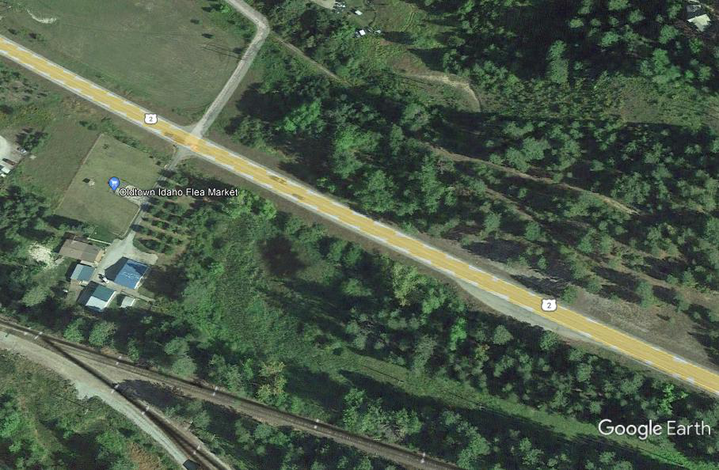

This ‘map’ is for RFP purposes only and should not be used as a ‘to scale’ version of the intended boardwalk and trail.

