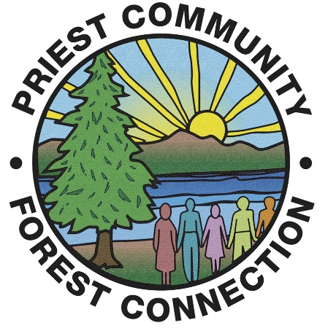
PCFC ELECTRONIC MEETING
January 2022
Please note that any voting item will have an asterisk by it.
- *December Meeting minutes
- Land updates ~ There is not much to report. Liz has been asked to participate in a peer group with Center for Creative Land Recycling which deals with communities that have and will be in a Brownfields project. (Apparently they think I have some knowledge. I told them sort of maybe…) CCLR deals with DEQ and EPA, but they will not be participating in the peer group. Yes, Steve Gill recommended me.
- *Financials ~
- The SBS meeting that was scheduled for January 12th was cancelled due to the weather conditions and will be rescheduled. (We are rescheduled for January 20th, 10 am.) In lieu of that, we do need to make some decisions. First and foremost is the LOC we have with Columbia. (Amy, please weigh in on this as you know the details.) Liz went through the renewal for that LOC and the question was asked: why do we need that when we clearly have money in our EJ account that could cover our programs. We originally put this in place for emergency overdrafts that rarely happened but have happened several times in the past couple of years. Part of this we discussed at out last meeting. One of the biggest solutions was for Liz to register for online banking with Columbia so she can track the balance on a daily basis which should alleviate that issue. (It took a while but Liz was able to get into the business account and will be able to check on balances before turning in bills.)
- RAC funds have been deposited in the account ~ finally. This is the funding we received for EXPO so basically this means have been paid back for our expenses Makes we wonder if we should re-apply for those funds for upcoming Expos. Jeff, you may have insight here as you are on that committee?
- Grant projections: Liz put in a grant application with Innovia for $20,000 for the Trail. We should hear about those funds April 1st. Avista grant cycle starts later this year and I will also put in an application for that.
- Other financials: SBS will send out our reports but at this time we are $85,300.00 in the EJ account (plus the $25,000)
- Upcoming costs: insurance will be due in about a month. That will be about $2000.
- My other thought is that once we set up the projection spreadsheet, this will all be so much more productive. I want to thank everyone for their patience and input. Best Board of Directors ever!!
- Upcoming topics ~
- Expo plans: Mike, we were going to bring more of the Tribe history, programs, etc into the workbook for the students. Also, we should start discussing the venue because it does not look good, right now, to count on the Experimental Forest.
- Liz needs to schedule the survey for the landfill but until we know and project our financials, she has not done that.
- Liz is working on getting an RFP out for the boardwalk and possible trail work. Obviously, funding will tell us how far we will be able to go this year. I am hoping to put boardwalk and trail into one RFP. But, we will not know our ongoing funds until we hear from grant funders. We know that material costs are way up and cedar will be quite expensive. Suggestions?

*NEXT MEETING: February 9th, 6:30 am ~ where? Please let Liz know if you are available.

